PRT Temperature Measurement Lab
Seth Ricks
ECEN 350
Brother Swenson
10/31/2025

ECEN 350 - PRT Temperature Measurement Lab (50 points)
(jas, PRT Temperature Measurement Lab.docx, 2/28/2025)

Note: This is a CAD lab to be done individually, rather than in teams, although please help each other out if/when opportunities arise, while still avoiding plagiarism. Submit an electronic version of a lab report to receive credit for doing this lab. The goal of your lab report is to provide sufficient documentation so that the lab can be repeated if necessary. Therefore, simply add to this document to arrive at your lab report, as all the explanatory text, procedures, and Discussion and Conclusion questions contained in this document are required for a complete lab report. So, for your lab report, add a cover page including class, lab title and author, your results, and your answers to the Discussion and Conclusions questions to the existing lab document. Your answers to the Discussion and Conclusions questions are to be uniquely yours and not a copy of someone else’s answers to these questions. Your cover page is to include class, lab title, and author. A grading rubric for this lab is included at the end of this document. The rubric does not need to be included in your lab report.
Purpose: The purpose of this lab is to better understand both the hardware and software aspects of practical Platinum Resistance Thermometer (PRT) temperature measurements.
Procedure:
Part 1 – PRT Measurement Circuitry and Simulation.
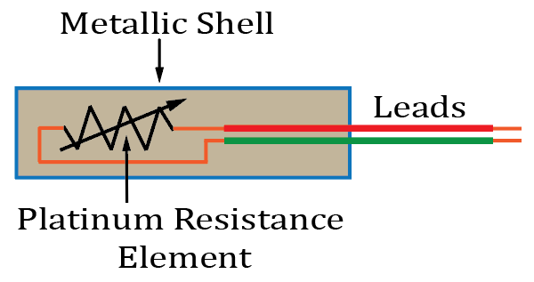
Temperature is one of the most widely measured physical quantities in the world today and is regularly accomplished by measuring resistance. Platinum Resistance Thermometers (PRTs) provide accurate temperature measurements based on the positive temperature coefficient of resistance (TCR) of platinum metal.

Figure 1: Platinum Resistance Thermometer (PRT).
The nominal resistance of PRTs is specified at 0˚C. Hence, the standard 1000 Ω PRT has a nominal resistance of 1000 Ω @ 0˚C, and a nearly constant TCR of approximately 3.85 Ω/˚C.

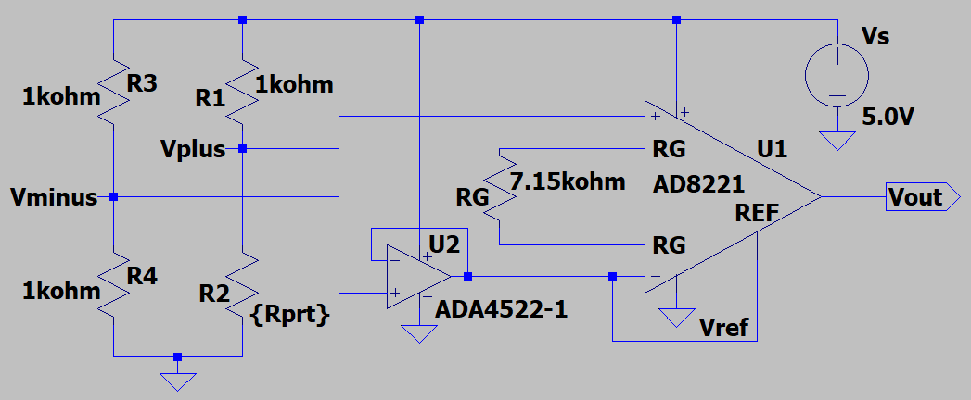
Because of a relatively small resistance change with temperature, PRTs are often measured using a Wheatstone Bridge, as illustrated below in Figure 2. In the circuit below, the Wheatstone bridge provides a small differential output voltage V_{plus} – V_{minus} that varies with PRT temperature. For a 1000 Ω PRT, V_{plus} – V_{minus} ideally equals 0 mV at a PRT temperature of 0 ˚C. In Figure 2, the relatively small differential V_{plus} – V_{minus} voltage from the Wheatstone bridge is amplified by the AD8221 Instrumentation Amplifier (IA), to provide a larger V_{out} signal to be measured.
Figure 2: Practical PRT Measurement Circuitry.
The single-ended, i.e., ground referenced, output voltage V_{out} from the above IA is to be digitized by an Analog-to-Digital Converter. In Figure 2, voltage divider resistors R3 and R4 provide a 2.5 V reference voltage on the V_{minus} node. Op-amp U2 is a voltage follower amplifier providing a constant 2.5 V to the V- and Ref pins of the AD8221, resulting in V_{minus} = V- = V_{ref} = 2.5 V. The resulting IA output voltage is given as follows: V_{out} = A_{V}(V_{plus} - V_{minus}) + V_{ref}, where A_{V} is the differential voltage gain as determined by resistor R_{G}.

To reduce the LTspice simulation run time, the circuit of Figure 2 can be simplified as shown below in Figure 3, where resistors R3, R4 and op-amp U2 are replaced by the 2.5 V voltage source named V_{ref}.

- Construct the PRT measurement circuit illustrated in Figure 3 in LTspice. The AD8221 IA symbol and model can be found in the LTspice [Opamps] parts library. This library can be accessed within the Select Component Symbol pane that opens when placing a part in LTspice by means of the component icon on the top toolbar. Add your name to your schematic by means of the following sequence: Edit Aa Text.
Replace the schematic shown in Figure 3 with your version. (12 Points.)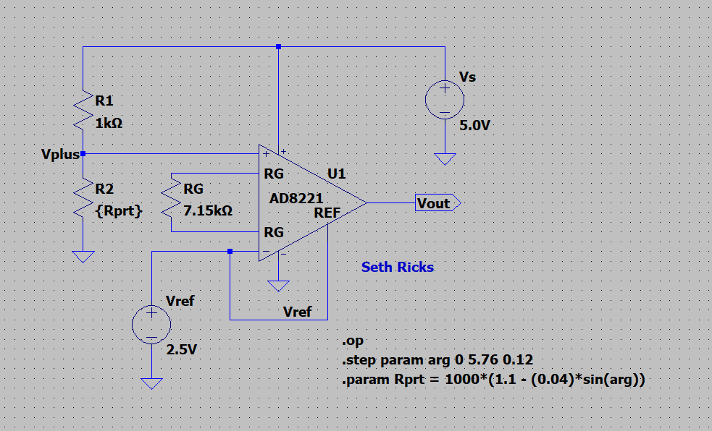
Figure 3: Simplified PRT Measurement Circuitry for LTspice Simulation.
The operating point, i.e. .op, command in conjunction with the .step and .param commands illustrated in Figure 3 result in an operating point analysis at several different PRT temperatures. The .step param arg 0 5.76 0.12 and .param Rprt = 1000*(1.1 - (0.04)*sin(arg)) commands illustrated in Figure 3 provide PRT resistance variations corresponding to typical summertime daily, i.e., diurnal, environmental temperature variations corresponding to the Earth’s rotation.

- After running the .op Analysis simulation, add a 2nd plot pane by means of the Plot Settings pull down menu as, Plot Settings Add Plot Pane. Select the V(vout) trace for the top plot pane and the V(vplus) trace for the bottom plot pane. Add a cursor to each trace and locate the cursors at 0 on the horizontal axis, corresponding to 0 radians for the arg parameter. Your V(vout) and V(vplus) voltages should match those shown in the figure below, else something is amiss with your simulation.
- Drag this cursor pane onto the Plot Pane, then resize the plot Pane to increase the height with respect to the width, resulting in a Plot Pane looking like the one shown in Figure 4 below. Then in the Plot Settings pull-down menu on the main LTspice toolbar, annotate your plot with your name as follows: Plot Settings Notes & Annotations Place Text.
- Replace the plot pane in Figure 4 below with your version, including the cursor pane illustrating appropriate voltages. (8 points.)
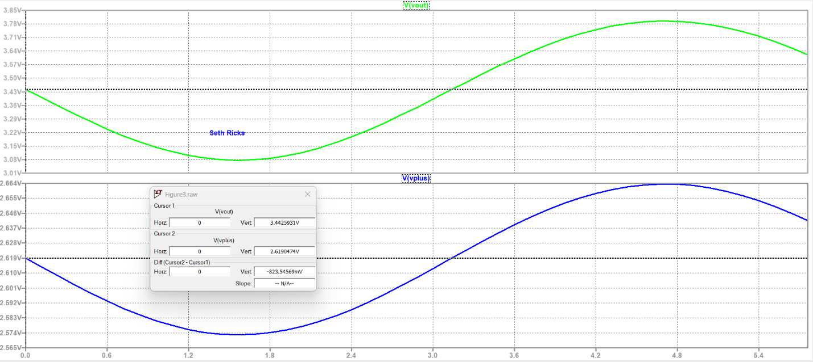
Figure 4: Simulated V_{out} and V_{plus} for the PRT Measurement Circuitry of Figure 3.
- Next your V_{out} simulation data is to be imported into MATLAB. This is to be accomplished by first exporting the LTspice data to a text file to be read in by MATLAB. In LTspice when the plot is selected choose the following selections: File Export data as text V(vout). The resulting text file will be named the same as name of your simulation asc file, except it will have the file extension txt. For example, an LTspice simulation file of name MyFile.asc will result in a text file of name MyFile.txt. Your txt file must be moved or copied into your MATLAB working directory for MATLAB to find the file. The txt file contains two columns of data, the 1st column being the arg parameter ranging from 0 to 5.76 radians in 0.12 radian steps, and the 2nd column being the associated V(vout) data. The txt file also contains the column headings arg and V(vout), which can be removed in MATLAB.
- In your MATLAB m-file include the following lines of code to read in the text file, remove the column headings arg and V(vout), form a column vector of output voltages, then take the transpose of the column vector to end up with a row vector of output voltages. As a precaution in your m-file, include the commands clear all, close all; near the beginning to clear variables and close any previously opened files.

Tab = readtable('MyFile.txt'); % Read in LTspice table data.
Tab1 = Tab.Variables; % Extract numeric data, eliminating column headings.
vt = Tab1(:, 2); % Form a column vector of V(vout) data.
vout = vt'; % Transpose V(vout) data to obtain a row vector.

MATLAB issues a warning that the Table variable names were modified, which can be ignored. Your resulting V_{out} vector should be a 1 row X 49 columns row vector, as indicated in the MATLAB Workspace window.

Part 2: Voltage to Temperature Conversion.

Practical PRT temperature measurements involve a combination of both hardware and software, with the software often written for a microprocessor or microcontroller. The purpose of the software is to convert the measured voltages to corresponding PRT resistance values, which are then converted to corresponding temperature values.

- From the AD8221 data sheet, determine the differential voltage gain A_{V} of the PRT Measurement Circuitry given in Figure 3, and include your calculations below.
(3 points.)
$$R_{G}=\frac{49.4kΩ}{R_{G}}+1$$
$$G=\frac{49.9kΩ}{R_{G}}+1=\frac{49.9kΩ}{7.15kΩ}+1=7.91$$
$$G=A_{V}=7.91$$

- The IA output voltage of Figure 3 equals V_{out} = A_{V}(V_{plus} - V_{minus}) + V_{ref}, where A_{V} is the IA voltage gain, and V_{minus} = V_{ref} = 2.5 V. Derive an equation for V_{plus} from the above expression, including your work below. As a check on your resulting V_{plus} equation, a V_{out} value of 3.5 V should result in a V_{plus} value of approximately 2.63 V. (3 points.)
$$V_{out}=A_{v}\left(V_{plus}-V_{minus}\right)+V_{ref}$$
$$V_{plus}=\frac{V_{out}-V_{ref}}{A_{v}}+V_{minus}$$
$$V_{plus}=\frac{3.5V-2.5V}{7.91}+2.5V=2.63V$$
$$V_{plus}=2.63V$$

- Based on the voltage divider circuit of Figure 3, derive an expression relating R_{prt} to V_{s}, V_{plus} and R1, including at least three steps in your derivation. As a check on your derived equation, a V_{plus} value of 2.5 V for the V_{s} and R1 values given in Figure 3 should result in an R_{prt} value of 1000 Ω. (8 points.)

$$V_{s}\left(\frac{R_{prt}}{R_{1}+R_{prt}}\right)=\frac{V_{plus}}{V_{s}}$$
$$R_{prt}=\frac{V_{plus}}{V_{s}}\left(R_{1}+R_{prt}\right)=\frac{V_{plus}}{V_{s}}\left(R_{1}\right)+\frac{V_{plus}}{V_{s}}\left(R_{prt}\right)$$
$R_{prt}=\frac{R_{1}}{\frac{V_{s}}{V_{prt}}-1}$
$C$heck: $\frac{1000Ω}{\frac{5}{2.5}-1}=1000Ω$

- Incorporate both your V_{plus} and R_{prt} equations into the same MATLAB m-file in which you imported your V_{out} simulation data from Part 1. (Note: Your resulting equation for R_{prt} requires element wise multiplication and division, whereas MATLABs definitions of the * and / operators correspond to linear algebra operations that are not at all like the element-wise operators. Hence, .* and ./ are needed to invoke element wise multiplication and division. See MATLAB help on the functions mtimes() and times() along with mrdivide() and rdivide() for more information.)

The PRT resistance versus temperature relationship is given by the Callendar-Van Dusen equation, given below for PRT temperatures ≥ 0 ˚C.

$$R_{prt}=R_{0}\left[1+aT_{C}+bT_{C}^{2}\right],where R_{0} is the PRT resistance at 0 ˚C,i.e., 1000 Ω,$$
and T_{C} is the temperature in ˚C.

The coefficients a = 3.9083 x 10⁻³ ˚C⁻¹ and b = -5.7750 x 10⁻⁷ ˚C⁻¹, from the International Temperature Scale of 1990, i.e., ITS-90, PRT calibration standard. Solving the above quadratic equation for temperature in ˚C results in the following equation:
$$T_{C}=\frac{-R_{0}a+\sqrt{R_{0}^{2}a^{2}-4R_{0}b\left(R_{0}-R_{prt}\right)}}{2R_{0}b}.$$
The above equation is to be used to convert from measured PRT resistance R_{prt} to temperature in ˚C.
- Incorporate the above equation for temperature $T_{C}$ into your MATLAB m-file with the V_{out} simulation data, along with your V_{plus} and R_{prt} equations. As a check on your temperature equation implemented in MATLAB, an R_{PRT} value of 1000 Ω should result in a temperature $T_{C}$ of 0˚C, whereas an R_{PRT} value of 1140 Ω should result in a temperature $T_{C}$ of 36.0˚C. Manually entering variable values into the Command Window, followed by copy and pasting equations from your m-file can be used to check your m-file equations.
- Run your resulting m-file to verify that the results are 1 x 49 element V_{plus}, R_{prt} at T vectors, corresponding to the 49 V_{out} voltages imported from the LTspice simulation. As a check, the first element of your temperature vector, i.e., $T_{C}$(1), should equal 25.7 ˚C.

Part 3: Diurnal Temperature Variation.

Outdoor air temperature exhibits a daily, i.e., diurnal, variation due to solar radiation changes caused by the Earth’s rotation. As a result, the coolest temperatures of the day typically occur near sunrise with the warmest temperatures typically occurring in the mid-afternoon. The next part of this lab is to plot PRT temperature variation over a 24-hour diurnal cycle in both ˚F (Fahrenheit) and ˚C (Celsius), based on your simulated V_{out} data from Part 1. MATLAB offers both left and right y-axis scales, which is to be used to plot both ˚F and ˚C temperature scales on the y-axis of a single plot.

- Generate a 49-element 24-hour time vector for plotting PRT temperature data over a diurnal cycle as follows: t = 0:0.5:24; % Hourly time vector.
- Implement a ˚C to ˚F conversion equation and generate a 49-element Fahrenheit temperature vector from the 49 element $T_{C}$ vector from Part 2.
- Next include the following MATLAB commands to plot PRT temperature in both ˚F and ˚C temperature scales on the same graph.

yyaxis left
plot(t, TF, 'b-'), grid on; % Temperature in Fahrenheit.
xlim([0, 24]);
xticks([0, 6, 12, 18, 24]);
xlabel('Hours past Midnight');
ylabel('See MATLAB Special Characters in Chart Help');
yyaxis right
plot(t, TC), grid on; % Temperature in Celsius.
ylabel('See MATLAB Special Characters in Chart Help');

- Include a ylabel() function that displays “Temperature ˚F”, for the yyaxis left axis, and another ylabel() function that displays “Temperature ˚C”, for the yyaxis right axis as shown below. See the MATLAB help for “Greek Letters and Special Characters in Chart” to see how to include the degree character ˚.
- Include a legend() function for your plot indicating ˚F and ˚C.
- Also include a title() function, with the following text “Diurnal Temperature Variation – Your Name”. Be sure to include your name in the title, rather than the text “Your Name”.
- After running your MATLAB m-file, a plot window opens in which you can drag the legend box away from the temperature traces, and also change the aspect ratio of your plot.
- Check the temperature values of your plot with the one shown below, as you should have a temperature of approximately 78.3 ˚F and 25.7 ˚C at time zero, corresponding to 12 am.
- Replace the plot below with your version, including your name. (8 points.)
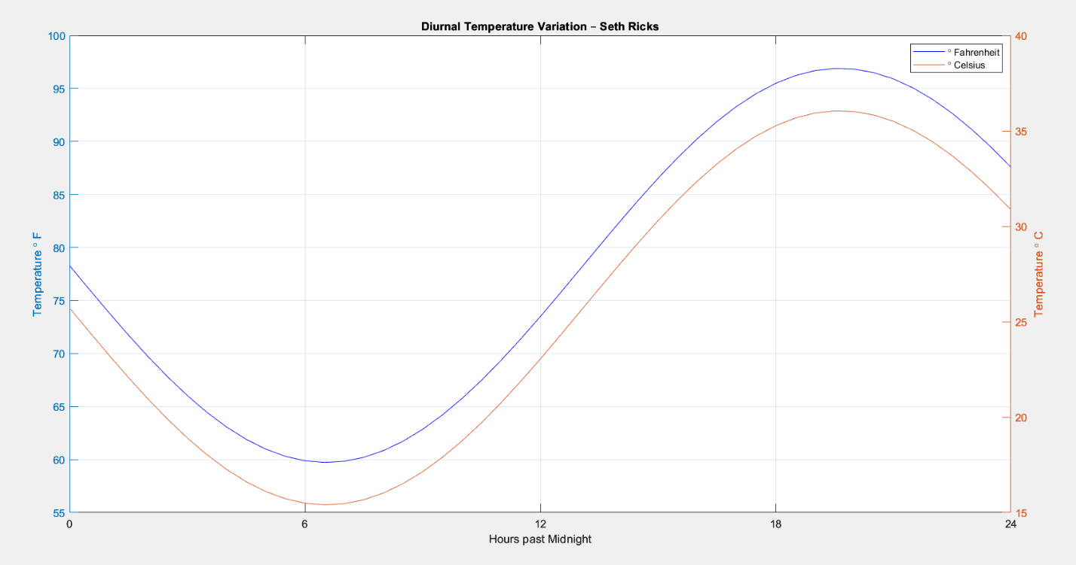
Figure 5: Practical PRT Measurement Results.

Part 4: Measurement Resolution.

The output voltage V_{out} from the Instrumentation Amplifier in Figure 2 is referred to as an analog signal, as it is continuous in time and amplitude and analogous to the PRT temperature being measured. An Analog-to-Digital Converter (ADC) is used to convert analog voltages into numeric values, represented by digital bits, for processing and storage. Since an ADC has a finite number of unique digital output bit combinations, the continuous amplitude analog signal is rounded or quantized in the analog-to-digital conversion process. The number of unique amplitude levels for an m-bit ADC, where m is an integer, equals 2^{m}. For example, a 12-bit ADC provides 2¹² = 4096 unique amplitude levels corresponding to the 4096 unique digital bit combinations. For an ideal 12-bit ADC with a 0 to 5 V input range, any two adjacent bit combinations corresponds to a difference voltage of (5 V)/2¹² = (5 V)/4096 = 1.22 mV, referred to as the voltage resolution. Input voltage changes less than the ADC resolution are not large enough to change the digital output, resulting in a digital version that only approximates the voltage levels of the original analog signal. In other words, an ADC cannot resolve input voltage changes less than the resolution. Hence, the ADC measurement resolution is an important metric regarding the conversion from a continuous amplitude analog signal to digital representation. You are to determine the temperature measurement resolution for the PRT Measurement system illustrated in Figure 2, for an ADC having m = 8, 10, 12 and 14 bits. This can best be accomplished by utilizing the vout, vplus, Rprt, TC and TF relationships previously implemented in MATLAB.
- An operating point is necessary to determine resolution. From your m-file that produced the diurnal temperature variation, determine, and record the following values as your operating point for determining the measurement resolution: vout(1), TC(1), and TF(1). 3.44, 25.71, 78.28
- Save your PRT Resistance to Temperature m-file under a new name so that it can be modified for the following resolution calculations.
- Enter into your new m-file your recorded vout(1), TC(1), and TF(1) values using new unique variable names such as vout1, TC1 and TF1.
- Delete or comment out with the comment character %, the readtable(), vt = Tab1(:, 2), and vout = vt’ commands, along with all of the plotting commands for your new m- file. As a result of these changes, the variables vout, TC and TF should now be scalars instead of 49 element vectors.
- Define a new variable m equal to the number of ADC bits, with m initially = 8.
- Define another new variable vres = (5 V)/2^{m}, which is the voltage measurement resolution.
- Set vout = vout1 + vres, corresponding to the minimum resolvable voltage increase from vout1.
- Define two new temperature resolution variables, TC_resolution and TF_resolution, to be calculated as TC_resolution = TC – TC1, and TF_resolution = TF – TF1.
- For values of m equal to 8, 10, 12 and 14, run your modified MATLAB m-file and record the resulting Voltage Measurement Resolution value vres, along with each TC_resolution and TF_resolution value below in Table 1 using at least 3 significant figures. As a check, for m = 8, your TF_resolution value should be approximately equal to 1 ˚F. (6 points.)

Table 1: PRT Measurement Resolution for Various Number of ADC Bits.
Number of Bits m | Voltage Measurement Resolution mV | Temperature Measurement Resolution ˚C | Temperature Measurement Resolution ˚F
8 | 0.019531250000000 | 0.562181309619273 | 1.011926357314692
10 | 0.004882812500000 | 0.140427159403028 | 0.252768886925452
12 | 0.001220703125000 | 0.035099412154420 | 0.063178941877950
14 | 3.051757812500000e-04 | 0.008774392054299 | 0.015793905697734

PRT Temperature Measurement Lab Grading Rubric: This is a CAD lab to be done individually, rather than in teams, although please help each other out if/when opportunities arise, avoiding plagiarism. Submit an electronic version of a lab report to receive credit for doing this lab. The goal of your lab report is to provide sufficient documentation so that the lab can be repeated if necessary. Therefore, simply add to this document to arrive at your lab report, as all the explanatory text, and procedures contained in this document are required for a complete lab report. So, for your lab report, add a cover page along with your results to the existing lab document. Your cover page is to include class, lab title, and author. The following rubric does not need to be included in your lab report.
Lab Report Item | Points
Cover Page | 2
Part 1 – PRT Measurement Circuitry and Simulation  Figure 3 - (12 points total. 7 point each for correct components including Vout net label (7 points total for components including Vout net label), 1 point for .op statement, 1 point for .step param arg 0 5.76 0.12 statement, 2 points for .param Rprt = 1000*(1.1 – (0.04)*sin(arg)) statement, 1 point for annotated name on schematic.)  Figure 4 – (8 points total. 1 point each for correct looking trace (2 points total), 1 point for 2 plot panes, 2 points for including cursor pane, 1 point for correct cursor V(vout) = 3.4 V at 0 radians, 1 point for correct cursor V(vplus) = 2.6 V at 0 radians, 1 point for annotated name.) | 20
Part 2 – Voltage to Temperature Conversion.  A_{v} calculation – (3 points.)  V_{plus} calculation – (3 points.)  R_{prt} calculation – (8 points.) | 14
Part 3 – Diurnal Temperature Variation.  Figure 5 - (8 points total. 2 points per trace (4 points total), 1 point for left y-axis label, 1 point for right y-axis label, 1 point for legend. -0.5 points each for not using ˚ symbol in left y-axis, right y-axis, or in the legend, 1 point for title.) | 8
Part 4 – Measurement Resolution.  Table 1: (6 points total. 0.5 points per entry. -0.25 point per each missing unit. Units in column headings are fine.) | 6
Total | 50
Please give feedback on errors you find in this document.

